ASSIGNMENT 6: NMAP

Name: Pratima Pore MIS: 112103111

DIV: 2 BATCH: B5

SUBJECT: Cryptography and Network Security

Task1: Find Open Ports On A System

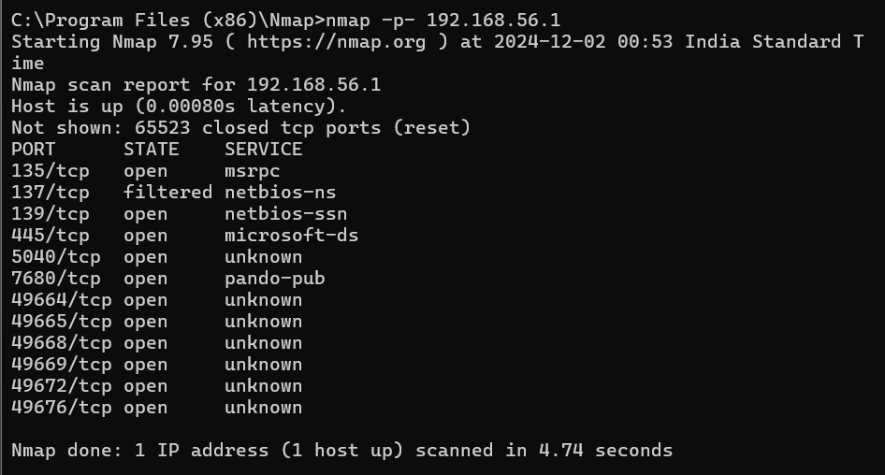

Task2: Find The Machines Which Are Active 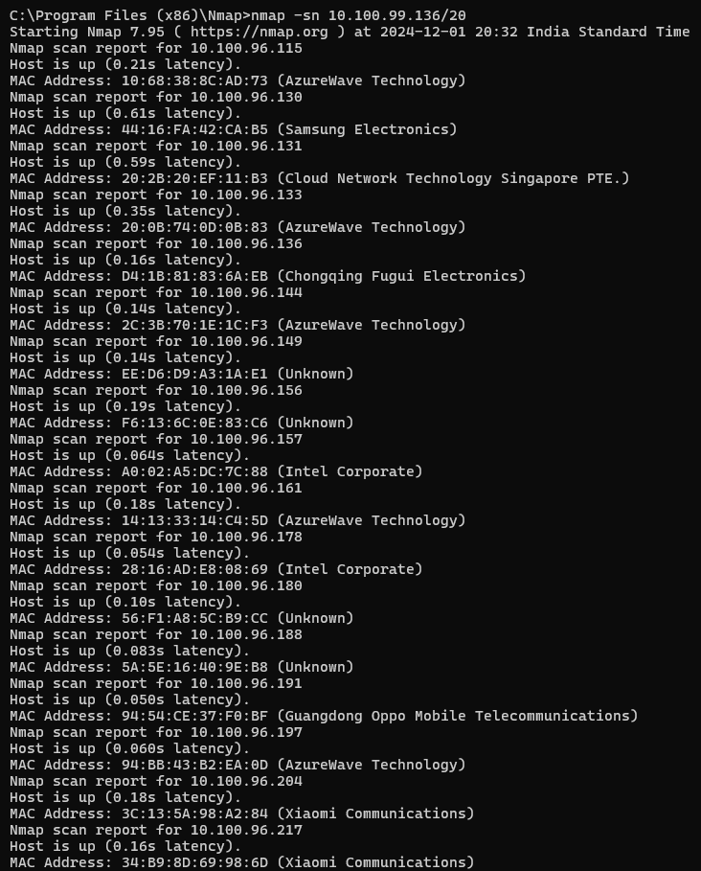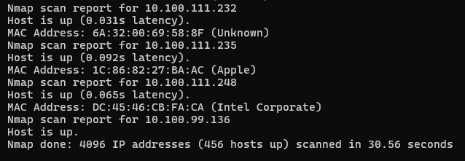

Task3: Find The Version Of Remote OS On Other Systems 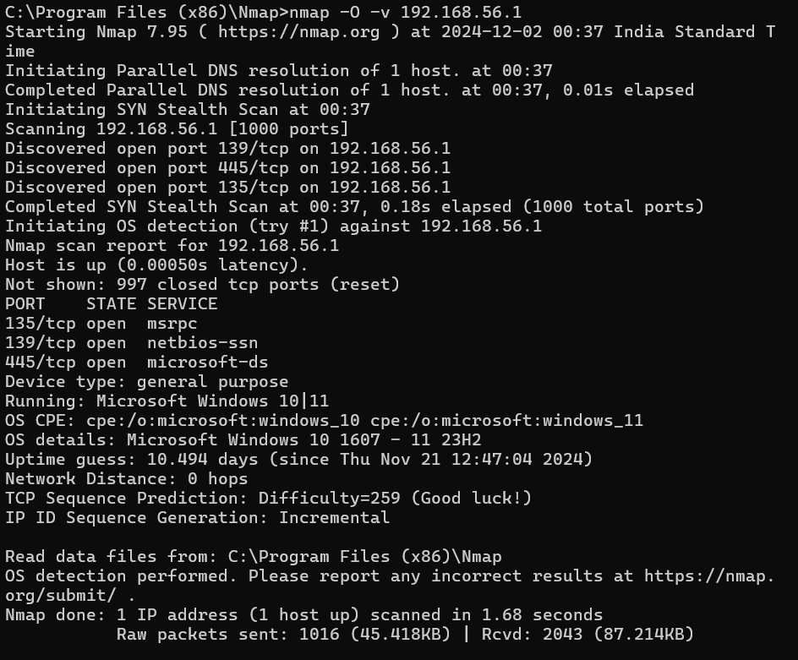

Task4: Version of software installed on other systems 